Workforce Planning Needs Assessment Guide:
How to Conduct a Customer
Workforce Planning Needs Assessment

Table of Contents
Introduction 2
Business Objective 3
Customer Perspective 4
Criteria for Success 5
Methodology/Analysis 6
Assumptions and Risks 7
Considerations 8
Template: Workforce Planning Needs Assessment Intake Form 9

Introduction

How to use this guide and sample intake form:
The objective of this tool is to help you understand your customer's workforce planning needs. Taking the time to determine your customer's true business objective and the underlying workforce planning implications can be the determining factor between a good workforce plan and a great one. This approach for conducting a WFP needs assessment will help ensure your workforce plan targeted and structured to produce the results your customer is looking for.
This guide can be used during the initial stages of developing a workforce plan as you are determining your customer's strategic direction. This tool will walk you through a guided inquiry that can be used with your customer to hone in on their specific WFP needs. Additionally, the corresponding workforce planning needs assessment intake form will help you capture the identified needs in a structured format.
Questions to consider:
- What is the business objective?
- Who is the customer and what is their perspective?
- What are the criteria for success?
- What methodology will you use?
- What are your assumptions?
- What data is required?
- What considerations are there?

Business Objective

What is the business objective?
In the context of workforce planning, the business objective is the primary reason and justification for implementing a workforce planning strategy, conducting a study, or making a change. When conducting a needs assessment, you may find that multiple conversations are needed before you can truly understand your customer’s business objective.
Questions to consider:

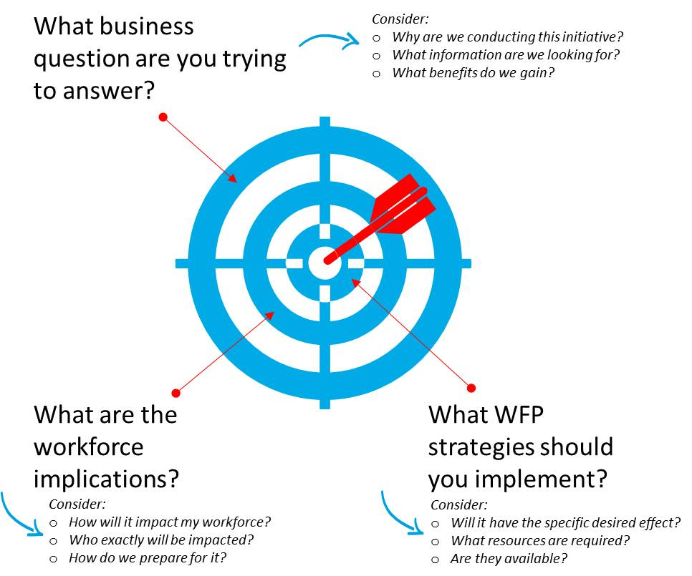

Customer Perspective

Keep your customer’s perspective in mind:
Understanding your customer’s perspective is key to conducting an accurate needs assessment. Your customers may be at varying levels or different offices within the organization so their key concerns might differ. However, the steps in conducting a workforce planning needs assessment for these differing customers generally remain the same. Often times the difference will be in how the “needs” question is asked. For example, you might ask one customer about the organization’s strategic direction and ask another how changing priorities affect their ability to have the proper staff in place.
Examples of Customers and Key Concerns:
The Director
Michael
The Division Director
Karen
The Program Manager
Robert

Michael is responsible for an entire business unit (ex: HR). He communicates regularly with the organization‘s executive leadership team and has multiple division directors as direct reports.

Key Concerns:
- Strategic Direction
- External business drivers
- Organization-wide resource constraints
Robert is responsible for a program area (ex: Grievance Processing Team). He reports to the Division Director and works closely with front-line employees and the public.

Key Concerns:
- Meeting workload goals
- Having the proper staff in place
Karen is responsible for a functional division (ex: labor relations) within a larger business unit (ex: HR). Karen reports directly to the director and communicates regularly with the leadership team within the business unit.

Key Concerns:
- Impact of organization‘s strategic direction on functional areas
- Ensuring key orgnizational functions continue operating

Tip: Do some research into your customer’s business priorities prior to the meeting. Use the information you gain to appropriately tailor the needs assessment to your customer’s priorities.

Criteria for Success

How will you know if you are successful?
After understanding what you are trying to achieve, you need to determine how you will know when you have achieved it. If the customer didn’t get what they want you can’t really say the initiative was successful. The development of metrics such as key performance indicators (KPIs) enable continuous monitoring of the project. With KPIs in place, your organization will be able to see where your process is working and where it can be improved. This knowledge will allow you to continually adjust your process to enhance its efficiency.
Key Performance Indicators - KPIs are quantifiable measures routinely used in performance improvement initiatives. Using KPIs will allow you to evaluate the success of your project and adjust the process to enhance its efficiency.
Examples:
- How satisfied are our customers?
- How efficiently do we process widgets?
- How fast are we resolving customer issues?

What does it look like if you are successful?
Criteria for success are the standards used to judge whether the initiative was successful from the perspective of your stakeholders.
While identifying business objectives is about what you will do, success criteria should allow you to say what you can do (that you previously could not).
In the context of workforce planning, think about:
- What was the desired organizational outcome?
- What are the specific enhanced capabilities?
- What specific benefits to the organization did it yield?
In addition, think about what outputs you might get at the end of the initiative.
Sample Outputs:
Supply Analysis | Demand Analysis | Gap Analysis
- Workforce-at-a-Glance Report  - Attrition Assessment  - Competency Assessment Report | - Summary of future workload  - Summary of future workforce requirements (capability and capacity) | - Prioritized list of workforce gaps (skills, capacity, capabilities)

Methodology/Analysis

How will you complete the task?
In an initial needs assessment, it is not necessary to concretely determine exactly how you would address the customer’s needs. However, you should think about potential methods you might rely on to address those needs and discuss them with your customer to ensure you will have access to the necessary data. Always remember to discuss data expectations with your customer early in the process to ensure there is an understanding from the outset.
Sample Methods:
Strategic Direction | Supply Analysis | Demand Analysis
- Environmental Scan  - Determining Mission & Vision  - Strategic Planning  - Executive Interviews | - Workforce Demographics Snapshot  - Labor Market Analysis  - Attrition Analysis  - Retirement Projections  - Succession Planning Projections | - Time Studies  - Workload Analysis

Once you have determined your methodology, consider:
- What data do I need? What data needs to go into the chosen methodology?
- How can I collect required data? What form will that data take? Will it need to be manipulated or cleaned?
- Who do I need to talk to? Who has access to that data? How does one get in contact with them?
Tip: Make maximum use of existing data (reports, strategic plans, previous studies) to avoid stakeholder fatigue, the feeling that “we’ve already done this … it’s a waste of my time.”

Assumptions and Risks

What are the assumptions and risks?
In assessing your customer’s workforce planning needs you will probably need to rely on assumptions related to strategic direction, budget, or the workforce, and also consider risks that might impact the success of a workforce planning strategy. Thinking through and validating those assumptions and risks explicitly with your customer will ensure that there are no misconceptions as you progress through your assessment. Having those conversations will also give you an opportunity to verify assumptions and risks from the perspective of your customer.
Assumptions - “Factors that are assumed to be true”
Examples of Assumptions:
- Available Staff
- Sufficient Budget
- Available workload capacity
- Staff with necessary skills
Are the assumptions you have the same as the customers? Are they valid?
Risks - “Things that might impact success”
Examples of Risks:
- Hostile business environment
- Stakeholder buy-in
- Organizational culture
- Data unavailability
Are the risks too significant to justify implementing the strategy? How can the risks be mitigated or eliminated?

Considerations

What other considerations should you factor in?
Other considerations that you may wish to think about in your needs assessment are: stakeholders, budget, prioritization, and level of effort. These other considerations may help build a more robust needs assessment and possibly involve other stakeholders that may want to weigh in.
Examples of other considerations:
Stakeholders
Budget
Prioritization
Level of Effort
- Who is the sponsor for this effort?
- Who else will benefit from this initiative?
- Who needs to be involved in designing this effort?
- Will this effort require additional funding?
- Do you have a budget approved for this work?
- What is the priority of this need compared to other business needs?
- Is it high, medium, or low on the priority list?
- How long is the effort expected to take?
- How many staff will it require to implement?
- How difficult will it be to find those staff?

Template: Workforce Planning Needs Assessment Intake Form
What is this tool? | A form that prompts you to capture the information you need to gather in order to understand the purpose and scope of a newly identified workforce planning need.
How do I use it? | Use this form to help guide the initial conversation(s) when a new workforce planning need is identified and in subsequent conversations to capture the information you need to fully understand the scope and purpose of the task. Please note that additional emails, call, or meetings with the initiator or project sponsor may be needed to capture all the relevant data. This form contains the basic structure for creating a needs assessment with labeled information categories and guiding questions. You may need to rearrange or omit certain sections based on your specific needs as they may not all be relevant.

Logistics
Date: | Insert date of discussion.
Completed By: | Include name and role.

Understanding the Need
Business Objective | What business question are we trying to answer?  What change are we trying to enact?  What information are we trying to discover?  What is the workforce implication of that business decision?
Success Criteria | What will our outputs be?  An end-to-end workforce plan vs. a point-in-time workforce planning study?  What is the desired organizational outcome?  What are the specific enhanced capabilities we want?  What information do we ideally want to attain or change we want to see in the organization?  What specific benefits to the organization will this yield?
Methodology/Analysis | What specific workforce planning analysis will be utilized?  What information will the analysis provide?
Required Data | What data is needed to complete this analysis?  Where might we find that data?  Is that data obtainable?  Does the data need to be cleaned or manipulated before use?
Assumptions | Are there any assumptions we must make in order to do this analysis?
Considerations | Are there any major risks?  Are there any contingencies?  What level of communication with stakeholders and impacted staff needs to happen?
Stakeholders | Who is the sponsor for this effort?  Who else will benefit from this initiative?  Who needs to be involved in designing this effort?  Who do we need to receive buy-in from?
Budget | Will this effort require additional funding?  Do you have a budget approved for this work?
Prioritization | What is the priority of this need compared to other business needs?  Is it high, medium, or low on the priority list?
Estimated Effort Time | How long is the effort expected to take?  How many staff will it require to complete? To implement?
Target Completion Date | Indicate desired completion date and the reasons behind it.
Additional Comments

