Business Case Guide:
How to Develop a Business Case
for Workforce Planning

Table of Contents

Introduction 2
Step 1: Establish the Need 4
Step 2: Outline Recommendations 4
Step 3: Costs and Benefits 6
Step 4: Assumptions and Risks 7
Step 5: Implementation Options 8
Step 6: Conclusion 9
Template: Workforce Planning Business Case 10

Introduction

How to use this guide:
The objective of this tool is to help you create your own business case for workforce planning. This guide will explain the different sections of a workforce planning business case and the attached business case template will help you organize your own. Once you have established the need for workforce planning, you can refer to other tools in the toolkit to implement your own workforce planning strategy.
A business case is an argument, usually in document form, developed to convince organizational decision makers to use resources to pursue a certain initiative. This tool lays out the key reasons why decision makers should take a proposed approach to solving workforce planning challenges. This tool also provides a high level template to help you develop your own business case for workforce planning.
What is workforce planning?
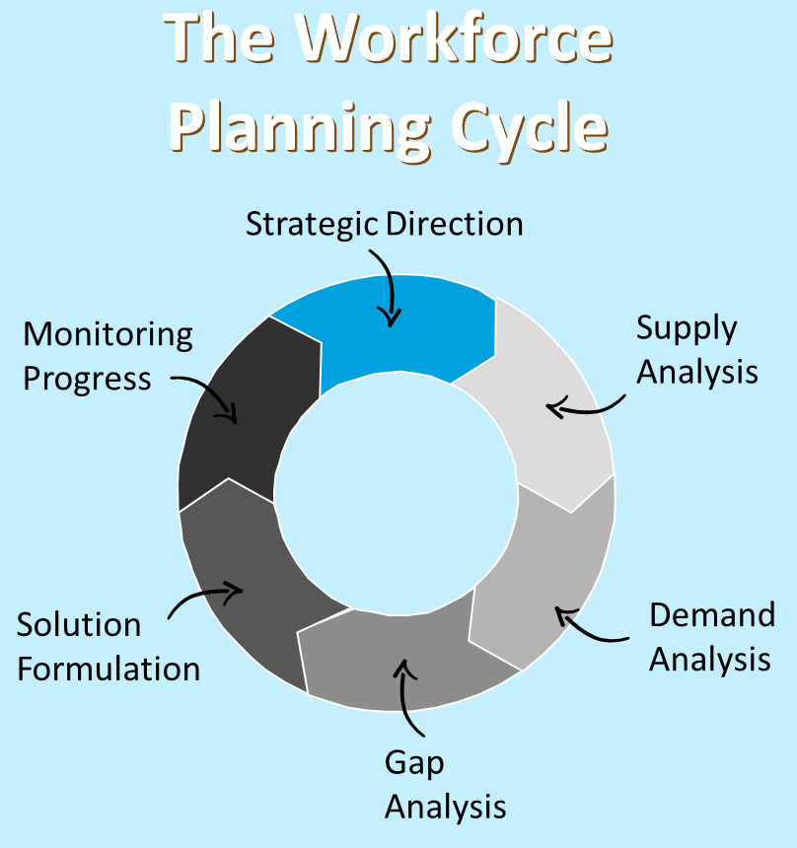
Workforce planning is the process of analyzing, forecasting and planning workforce supply and demand, assessing gaps, and determining targeted talent management interventions to ensure that an organization has the right people – with the right skills in the right places at the right time – to fulfill its mandate and strategic objectives.
Workforce planning is composed of six phases:
- Strategic Direction
- Supply Analysis
- Demand Analysis
- Gap Analysis
- Solution Formulation
- Monitoring Progress
Why do workforce planning?
The federal government environment today is one of rapid change and uncertainty. Changing political direction, rapid technology advances, and increased pressure to do more with less, are just some of the factors leading to increased pressure on organizations, to ensure that the required talent is in place to effectively respond to changing business priorities.
When properly implemented, workforce planning ensures an organization has the right people with the right skills in the right places at the right time. These factors, people, skills, positions, and timing, need to be aligned to ensure your organization is able to continue to meet its mission.

What are the benefits of workforce planning?
As you develop your business case for workforce planning, it is important to discuss the tangible benefits workforce planning can have on your organization to engage business leaders and emphasize the value of this effort. The more tangible and relevant the benefits are to your specific organization, the stronger your business case. If you are having trouble thinking of benefits specific to your organization, think instead of what might happen if you do not take action. When properly implemented, workforce planning can:
- Identify staffing levels and competencies required to support both short- and long-term strategies and goals to minimize the chance of workforce misalignment.
- Address gaps between the current and desired future workforce and defines these talent surpluses and shortages.
- Align the workforce with business plans to appropriately target and prioritize skill requirements and transition strategies.
- Support organizational change efforts and create a roadmap to achieve an ideal future workforce.
“A business case can be very general and concise with high level qualitative arguments or be very lengthy and in-depth with large amounts of quantitative data and models depending on your needs.”

Step 1: Establish the Need

What can workforce planning help resolve?
The first step to building a case is identifying an organizational challenge or issue that workforce planning can help resolve. Workforce challenges often arise due to a high-level change in mission or shift in skills need.

Common challenges workforce planning can help resolve:
Skill Gaps
Budget Cuts

A change in an agency’s mandate can mean a change in the scope or needs of its work. By having an active workforce plan an agency will be in a position to proactively reshape its existing and future workforce skills profile to meet new mission needs.
Often times an organization’s skills needs will shift over time. By using workforce planning, an organization will know where it has existing skillsets, and can internally streamline position transitions with relative ease.
By strategically planning its workforce, an organization will know where there is a skill need for its current and future state, allowing it to strategically plan talent distributions to meet mission needs of today and tomorrow.
gnment

Step 2: Outline Recommendations

Realignment
Change in Mandate
By strategically planning its workforce, an organization can ensure that it has access to the skills needed to meet current and future mission needs despite changes to budget.

How can workforce planning help resolve the issue(s) identified?
The next step is to clearly lay out what your proposed workforce planning solution is and clearly state how it will address the issue(s) you identified earlier. Remember, workforce planning does not need to be sophisticated to add value to an organization.
Question your proposed recommendations should answer:
Why am I proposing the implementation of workforce planning? How will it address the identified issue?
Reflecting back on the organizational challenges you identified for this case, think about how the proposal will specifically address the issue. Make it very obvious to the reader!

What is the scope and vision of my proposal?
Discuss how the proposal is feasible given any constraints that may be facing you or the organization. Sometimes the best solutions are the simplest ones. Lay out for the reader how the proposal’s vision and scope is appropriate within the context of your organization.

What is my ideal vision and outcome from the proposed implementation?
In order to persuade organizational decision makers to implement the proposal, it is important that the benefits of the proposal are clearly articulated. Additionally, it is important to thoroughly consider and define the goals of the proposal so that the implementation process has clear direction. What are the ideal outcomes of your approach? Is there a clear direction? Does it add value to your organization?

Step 3: Costs and Benefits

What are the costs and benefits?
Are there any potential costs to implement the proposed solution? There are manpower costs (how many people would it take) and operational costs (if we do this, what falls off the plate). What are the benefits to implementing the proposed solution (the benefits should outweigh the costs)? Beyond the intended benefits and outcomes think about any secondary benefits or longer-term benefits that might arise.
Tips for thinking about costs and benefits:

Qualitative
- Service quality, flexibility, scalability, compliance, customer-centric service delivery, and the ability to be more “strategic.”
Quantitative
- Headcount reduction: Salaries, benefits, bonuses
- Technology savings: Hardware, software, maintenance, upgrades, licenses, vendors
- General and Administrative savings: Utilities, insurance, rent, supplies, communications
- Other savings: Rent, furniture, legal and consulting fees, printing, travel
Operational
- How would workload need to shift if this was implemented? What would not get done?
- What might happen if the proposal isn’t implemented?
Types of Costs
- What is the initial cost (current fiscal year)?
- Are there ongoing costs (maintenance)?
- What are the one-time costs vs. recurring?
Manpower
- How many people would it require to implement?
- Are those people identifiable and available?
- If not, is there a cost to finding them?
Costs
Examples:
Examples:
Benefits

Step 4: Assumptions and Risks

What are the assumptions and risks?
What are the assumptions that the proposal is dependent on (i.e. what factors are "assumed" to be true)? This could be anything from assumptions about staff that will be available, budget that will be available, technology that will integrate properly, etc. It is important to communicate these things to the reader to ensure they agree with those assumptions. Additionally, what risks are there that the reader should be aware of that might impact the success of the proposal (i.e. things that might impact success)? How might these risks be mitigated or eliminated?
Assumptions = “Factors that are assumed to be true”
Examples of Assumptions:
- Available Staff
- Sufficient Budget
- Available workload capacity
- Staff with necessary skills
Provide a detailed listing of the assumptions you used in your cost/benefit determination and your overall proposal.
Risks = “Things that might impact success”
Examples of Risks:
- Hostile business environment
- Stakeholder buy-in
- Organizational culture
- Data unavailability
Are the risks too significant to justify implementing the strategy? How can the risks be mitigated or eliminated?

Step 5: Implementation Options

What are the implementation options?
Describe the different options for implementing the proposal and discuss the pros and cons of each option. What is the recommended option and why? Does the proposal need to be implemented all at once to be effective? Can it be done in phases or in a piece-meal approach? Would that affect its organizational impact?
Approach Examples:
“Big Bang”
- Implementation of proposal will be completed all at once

Phased
- Implementation of proposal will be completed over an estimated set of years
Examples of Additional Items:
- Timelines
- Estimate of Resources
- Required
- Project Tollgates
- Post-project evaluation plan

Step 6: Conclusion

How do you tie it all together?
The final step is to reiterate the benefits of your proposal, qualitative and quantitative, and link them to the reader's strategy and core concerns. You should also state the immediate next steps. Finally, remember to include the executive summary (easier to complete at the end).
Convince them to care
How does it address the stakeholder’s core concerns and strategy?
State the benefits to the stakeholder
What is being gained by implementing this proposal (or being prevented)?
Immediate Next Steps
What actions need to be taken to get started?

Template: Workforce Planning Business Case

Executive Summary
Executive Summary for overall Workforce Planning Business Case
Provides a business rationale for the development of the workforce plan. Provides a high-level overview of the information contained in the rest of the template.

Step 1: Business Need
State the organization challenges related to workforce planning

e.g. budget cuts impacting workforce, skill gaps, shift in skills needs, etc.
State how the challenges affect the organization’s ability to meet its mission
State how workforce planning would help the organization overcome the identified challenges

Step 2: Outline Recommendations
State the recommended workforce planning solution for overcoming these organizational challenges
State the scope and vision of this proposal/ recommendations
State the ideal outcome of this proposed action

Step 3: Costs and Benefits
State the expected initial costs and the ongoing costs of implementation
State the anticipated manpower costs of implementation

i.e. how many people would implementation require, are those people available, if not then what will be the cost of finding them, etc.
State the anticipated operational costs of implementation

i.e. how would workload need to shift if this implementation occurred, what work or alternative projects would not get done, what could happen to the organization if this proposal isn’t implemented, etc.
State the anticipated quantitative benefits of this proposal

i.e. technology savings, headcount savings, administrative savings, etc.
State the anticipated qualitative benefits of this proposal

i.e. organizational flexibility, improved service quality, the ability to operate more strategically, etc.

Step 4: Assumptions and Risks
List the organizational assumptions used in the cost/benefit analysis and overall proposal

i.e. there will be available staff, there will be staff with necessary skills, there will be sufficient budget, etc.
List the risks anticipated as potentially impacting the success of this proposal

i.e. organizational culture, stakeholder buy-in, data unavailability, hostile business environment
Explain how the risks will be overcome or mitigated

Step 5: Implementation
Summary of the proposed implementation plan
Relevant Timelines
Estimated Resources Required

i.e. how many people will it take to conduct this implementation?
Project Tollgates

i.e. what are the project milestones?
Post-Project Evaluation Plan

i.e. how will success of the project be measured?

Step 6: Conclusion
Summarize the organizational benefits of this proposal
Organizational core concerns and strategy are addressed by:
The immediate next steps toward implementing this proposal are:

